**Design**: 2 (*Stimulus:* Target 1 sharing a common size with positive sources vs. Target 2 sharing a common size with negative sources) within-subject design. Method factors varied between participants:

* + - *Stimulus identity*: Target 1 or 2 assigned to match size of positive or negative sources
    - *Order of evaluative measures*: EP before vs. after self-reports

**Stimuli.** Two nonsense words (MORAG and STRUAN) will serve as Target 1 and Target 2. Six positive (*Rainbow, Pleasure, Smile, Love, Paradise, Joy*) and six negative adjectives (*War, Cancer, Hate, Hell, Misery, Vomit*) will serve as valenced sources.

**Participants.** Data-collection will be via the Prolific website (prolific.achttps://prolific.ac/). Given the unreliable nature of the evaluative priming task, large sample sizes typically required to find EP effects, and our uncertainty about the size of the EP effect we might obtain, we opted to use a Sequential Bayes Factor (SBF) design with a maximal N (e.g., Schönbrodt, & Wagenmakers, 2018). Specifically, we will use a threshold of > 3 or < 0.16, a minimum of 300 participants, an addition of 100 participants for each test, and a maximum of 500 participants (which was the maximum number our resources allowed).

Specifically, after collecting data from 300 participants, we will compute the BF for the evaluative priming effect (given that this is the primary effect of interest in Study 8: see *data analysis* document). If the BF does not exceed the aforementioned thresholds, we will increase the sample size by 100 and then compute the BF again. We will do it until the threshold is reached or exceeded or until we collect data from 500 participants.

**Procedure.** Acquisition phase 🡪 Evaluative measures 🡪 Exploratory Questions

*Acquisition phase*. Participants receive three blocks of 16 trials (48 total) consisting of two different types of trials. In one type of trial target 1 is presented in the same sized font as positive words and a different sized font as negative words. In another type of trial target 2 is presented in the same sized font as negative words and a different sized font as positive words. Note that each trial will contain three stimuli simultaneously presented onscreen: a neutral word (MORAG or STRUAN) and positive and negatively valenced words. All three stimuli will initially be presented for 5000ms, after which all stimuli will be removed, followed by an inter-trial interval of 750ms, and the next trial. Stimuli will always be presented in the same color (white) and the sizes of the fonts will be randomly counterbalanced across trials (e.g., sometimes a target and source share a small font and at other times they share a large font).

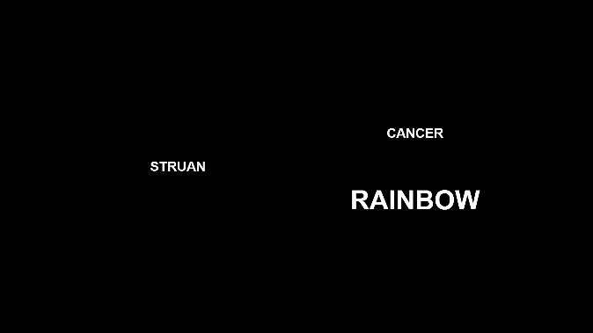 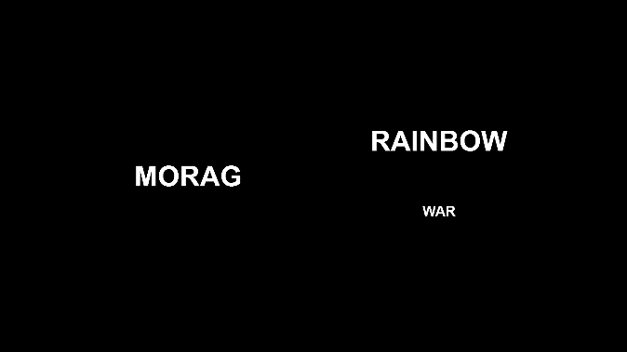

*Figure 1.* Examples of two types of trials in the acquisition phase.

*Implicit measure (Evaluative Priming Task).* To measure implicit evaluations, we will use an evaluative priming task in which participants are asked to categorize target words as either positive or negative using the E and I keys of a computer keyboard. During all trials, the labels “good” and “bad” will appear on the lower left and right corners of the screen. In line with the procedures of earlier studies (e.g., Spruyt, De Houwer, & Hermans, 2007), a single trial will consist of a fixation cross presented for 500 ms, a blank screen for 500 ms, a prime for 200 ms, a blank screen for 50 ms, and the presentation of a target word. Targets will be presented in white font against a black background. The inter-trial interval will be set to vary randomly between 500 ms and 1500 ms. Whenever an incorrect response is made or participants do not respond prior to the response deadline of 1500 ms, ‘Wrong’ will be displayed in the center of the screen for 250 ms before the next trial. Participants will be asked to respond as quickly as possible without making too many errors.

The two nonwords MORAG and STRUAN will be used as prime stimuli. Targets will consist of 10 positive words (e.g., Fantastic, Great, Nice) and 10 negative words (e.g., Terrible, Disgusting, Nasty). With the two types of primes and two types of targets, there will be four prime-target combinations. Participants will first complete eight practice trials, which will be followed by 80 critical test trials. The test trials will be presented in a single block of 80 trials, with each of the four types of prime-target combinations presented twenty times in random order (i.e., two times Morag – with each of the ten positive targets; two times Morag – with each of the ten negative targets; two times Struan – with each of the ten positive targets; two times Struan – with each of the ten negative targets).

*Explicit measure*. Participants will give explicit ratings of the two targets by answering the question:

*“Please rate the above item using the scale below*  
options: -5 =Negative, 5= Neutral, +5= Positive

options: -5 =I Dislike it, 5= Neutral, +5= I Like it

options: -5 =Bad, 5= Neutral, +5= Good

options: -5 =Unpleasant, 5= Neutral, +5= Pleasant

*Intention measure*. Participants are presented with two brand products labeled with either TARGET 1 or TARGET 2. They are asked to indicate which of these products they would try and given the following options: “I would try TARGET 1, I would try TARGET 2, I would try neither”.

Finally, participants answer the following exploratory questions about the EC task:  
  
 *Source-Target Contingency awareness*. “In the first part of the experiment we presented MORAG/STRUAN along with two other words. Did...?

“Those two other words always have a positive meaning", "Those two other words always have a negative meaning", "One word always have a positive meaning and the other a negative meaning", "I don’t remember"

*Source-Target Size Contingency Awareness*. Questions were as follows:

“Think back to the first part of the experiment (where the three words were presented together onscreen). Was MORAG always presented in:"

“Think back to the first part of the experiment (where the three words were presented together onscreen). Was STRUAN always presented in:"

Response options: The same size letters as POSITIVE Words", "The same size letters as NEGATIVE words", "I don’t remember"

*Manipulation check*.

“Did you ever take notes (or write down) what happened in order to help you figure out what was going on? Please be honest here (you will receive payment regardless of what you say).”

*Demand Compliance (explicit):* Earlier you rated MORAG and STRUAN as being either positive, neutral, or negative. Did you base your ratings NOT on how you actually felt about those words but on what you thought the researchers wanted you to say?"

("Yes", "No", "I don’t know")

*Demand compliance (implicit).* Earlier you completed the Implicit Association Test (see below). Did you base your performance in that task NOT on your best efforts to perform the categorizations as quickly and accurately as possible but on your attempt to influence your speed or accuracy in order to go along with what you thought the researchers wanted you to feel about the words?

("Yes", "No", "I don’t know")

*Reactance. (Explicit).* Earlier you rated MORAG and STRUAN as being either positive, neutral, or negative. Did you consciously resist what you thought the researchers wanted you to feel about those words?"

("Yes", "No", "I don’t know")

*Reactance (implicit).* Earlier you completed the Implicit Association Test (see below). Did you try to influence your speed or accuracy in order to consciously resist what you thought the researchers wanted you to feel about those words"

("Yes", "No", "I don’t know")

Influence Awareness.

“Think back to the first part of the experiment. During that part of the study, we presented MORAG and Positive Words in the same sized letters and STRUAN and Negative Words in the same sized letters. Did you notice this during the study? Please be honest here"

“Do you think that the fact that MORAG and Positive words were presented in the same sized letters (and that STRUAN and Negative Words were presented in the same sized letters) influenced how you rated or otherwise responded towards MORAG or STRUAN? Please be honest here"

Note: the target and source identity in this question was counterbalanced across experimental conditions.